
TABLE OF CONTENTS
1. Letter From Secretary General
2. Letter From Under Secretary General
3. Introduction To The Committee
4. Introduction To The Agenda Item
5. Previous Actions Taken By The United Nations
6. Related Terms
7. Reasons Of Violence Against Women
8. Current Situation in Middle Eastern Countries
9. Further Reading
10. Questions To Be Addressed

1. Letter From Secretary General
Dear Delegates,

First of all, it is my utmost pleasure to serve you as the Secretary General for Antalya Private Yükseliş High School Model United Nations Conference. I am more than proud for making this conference happen with my friends and waiting with a great enthusiasm to see every participant.

MUN’s are great opportunities to discover your talents, improve your formal communication abilities and understand how policy is implemented. For these reasons, as a great academic team it is our mission to transfer our experiences to the new generation and to ensure that MUNs affect them in a similar way.

Lastly as executive team, we put everything we had into this conference. My most sincere regards. Welcome to Ascend of Prestigiousness!

Yusuf Almış
2. Letter From Under Secretary General
Dear delegates,
I am honoured to welcome you all to the YKMUN24' It is a pleasure to serve you as the Under Secretary General. I expect great committee flow and want you to push your limits to the best, therefore I highly encourage you to read the study guide carefully and do not forget to do extra research about the Questions to be Addressed. Everything aside, I hope you can have a great time with the time you spend in the sessions and the conference.
Lastly, I would like to thank our Secretary General Yusuf and our Deputy Secretary General Neva for their efforts and for inviting me as an Under Secretary General.

Sincerely,
Muhammet Gökhan YILDIZ
(Under Secretary General)

For any situation don't hesitate to contact me via +90 551 010 9291

3. Introduction to the Committee
The United Nations Entity for Gender Equality and the Empowerment of Women (UNWOMEN) was established in July 2010 as a response to the requirement for a dedicated entity to defend gender equality and women's empowerment throughout the world. It merged the efforts of four similar organizations and aimed to organize the United Nations' actions upon gender issues.
The existence of gender-based and honor-based violence in war zones and developing countries makes it too hard for women to survive.
Today, UNWOMEN is gathering today for suffering women, especially for the ones suffering because of the ongoing war.

4. Introduction to the Agenda Item
Violence against women is a violation of human rights that transcends geographical, cultural, and socio-economic boundaries. In the context of the Middle East, where complex cultural dynamics, traditions, and ongoing socio-political challenges intersect, the issue of violence against women requires urgent and focused attention.
UWOMEN aims to address the multifaceted nature of violence faced by Middle Eastern women, including domestic violence, honor-based violence, and gender-based violence.

5. Previous Actions Taken By The United Nations
- Declaration on the Elimination of Violence Against Women (1993)
The Declaration on the Elimination of Violence Against Women was adopted by the United Nations General Assembly in December 1993. It is a pivotal document that outlines the international commitment to eradicate violence against women, recognizing it as a violation of human rights and a form of discrimination.
The Declaration emerged in the early 1990s as awareness of violence against women grew as a global issue. The UN recognized that such violence is deeply rooted in gender inequality and discrimination, prompting the need for a formal commitment from member states.

- Resolution 1325 (2000)
This Security Council resolution emphasizes the importance of women in peace and security processes and calls for their protection in conflict situations.
United Nations Security Council Resolution 1325, adopted on October 31, 2000, is a landmark resolution that addresses the impact of armed conflict on women and recognizes their role in peacebuilding and conflict resolution.
Resolution 1325 has had a significant influence on international policy and practice regarding women, peace, and security (WPS).

- UN Commission on the Status of Women (CSW)
The CSW was established in 1946 as a functional commission of the UN Economic and Social Council (ECOSOC).
This body regularly discusses and advocates for measures to eliminate violence against women and girls.
Its aim is to address problems affecting women globally and to promote their rights, focusing on social, economic, political, and educational advancements; Preventing violence against women and girls; Sustain economic empowerment and labor rights; give access to education and technology worldwide; encourage women's participation in decision-making and leadership roles.

6. Related Terms
- Honor-based Violence:
It refers to violent acts committed to protect or restore the perceived honor of an individual and family, often based on cultural, religious, or societal norms. This type of violence is typically directed at women but can also affect men at some points. Honor-based Violence often rooted in traditional beliefs about family honor, morality, and gender roles. In many cultures, a woman's behavior is seen as a reflection of her family's honor. Honor-based Violence also includes forced marriage.

- Domestic Violence:
It refers to a pattern of abusive behavior in an intimate relationship used by one partner to gain or maintain power and control over another. It can occur in various forms and affects individuals regardless of gender, age, race, or socioeconomic status. It mostly affects women and the children but in some situations men may also suffer from domestic violence. Includes financial abuse, emotional abuse, manipulation, physical and psychological violence.

- Gender-based Violence:
It refers to harmful acts directed at individuals based on their gender. It encompasses a wide range of violence that affects both women and men, though women and girls are disproportionately affected. Gender-based Violence is rooted in gender inequality, discrimination, and social norms that perpetuate violence. It mainly includes physical violence and sexual assault.

- Sexual Assault:
Sexual assault is often influenced by societal attitudes towards gender, power dynamics, and cultural norms. Victim-blaming and stigma can further complicate survivors' experiences and willingness to seek help. Survivors of sexual assault may experience a range of physical and emotional effects, including injuries, sexually transmitted infections, anxiety, depression, post-traumatic stress disorder, and social withdrawal.

- Victim-Blaming
It is the phenomenon where victims of a crime or harmful act are held partially or fully responsible for the harm they have experienced. This attitude often shifts the focus from the perpetrator's actions to the victim's behavior, choices, or circumstances. It is mostly related to sexual assault.

7. Reasons Of Violence Against Women
- Psychological Background
The tendency for men to exhibit violent behavior is one of the main reasons for this issue. A father's antisocial behavior and having a manipulative and narcissistic personality can lead to a child growing up in a similar manner. Physical or emotional violence within the home, excessive control, and restrictive behaviors can also contribute to a child's inclination toward violence.
If there is a patriarchal structure in the household, and if the daughter is belittled by her parents, this can cause the son to see himself as a superior being. This situation, related to social learning, is one of the fundamental factors contributing to the increase in violence against women.
- Cultural Background
A decline in cultural standards brings about the degradation of women. Lack of education and underdevelopment argue that women should not be a part of society. It resists the changing world order and cannot adapt to this transformation. An increase in educational levels will reduce the rates of violence against women.
- Religious Background
One of the factors contributing to the increase in violence against women is excessive adherence to religion. The inability to adapt to new situations that did not exist in the old order—such as women's entry into the workforce, taking on more significant roles in society, and the sharing of household chores between men and women—gives rise to a hatred toward women. Situations like women dressing openly or being out at night are met with hostility. Women who do not adhere to social norms are devalued and are often the targets of hatred. This is parallel to the cultural background.
8. Current Situation in Middle Eastern Countries
- Israel-Palestine Conflict:
The Israel-Palestine conflict is a long-standing and deeply rooted struggle over land, identity, and sovereignty, with origins in the late 19th and early 20th centuries, when both Jewish and Arab nationalist movements emerged. Following World War I, Britain controlled Palestine, and the 1917 Balfour Declaration supported a Jewish homeland, leading to increased Jewish immigration and rising tensions with the Arab population.
In 1948 Arab-Israeli War resulted in Israel's declaration of statehood, significant territorial expansion, and the displacement of many Palestinians, creating a refugee crisis. The 1967 Six-Day War further intensified the conflict as Israel occupied the West Bank, Gaza Strip, and East Jerusalem. Key issues include territorial disputes, the status of Jerusalem, the right of return for Palestinian refugees, and Israeli settlements in the West Bank, which are deemed illegal by most countries.
Recent developments include periodic escalations of violence, particularly in Gaza, and normalization agreements between Israel and some Arab states, which have shifted regional dynamics. Despite various peace efforts, a lasting solution remains elusive, with a two-state solution facing numerous challenges, including political divisions among Palestinians and ongoing settlement activity, perpetuating a cycle of violence and humanitarian suffering. This suffering cycle creates the lack of security for not just men but also women and the children with the existence of sexual, domestic, gender based and honor based violence.
- Situation in Iran
The situation of women in Iran is complex and has seen significant shifts over the years, marked by both advancements and ongoing challenges. Before the 1979 Islamic Revolution, women made considerable strides in education and employment, including the right to vote granted in 1963. However, the revolution led to strict interpretations of Islamic law, resulting in significant rollbacks in women's rights, such as the enforcement of mandatory hijab and more restrictive social norms. While women have achieved higher enrollment rates in universities than men in recent years, their participation in the workforce remains limited by societal norms and legal barriers. Legal inequalities persist in areas like inheritance and divorce, where women's rights are often subordinate to those of men.
Recent protests, particularly following the death of Mahsa Amini in 2022, have seen women at the forefront demanding greater freedoms and rights, despite government crackdowns on dissent. While traditional views on gender roles still dominate, a growing movement among younger generations is advocating for gender equality, highlighting both resilience and resistance in the face of systemic oppression.

- Situation in Iraq
The situation of women in Iraq is marked by both challenges and progress, shaped by years of conflict, social change, and evolving gender roles. Women face significant human rights challenges, including gender-based violence, harassment, and discrimination, particularly in the aftermath of the ISIS occupation, which targeted women and girls. While the defeat of ISIS has improved security in some areas, violence and societal norms still pose risks to women’s safety. Access to education has improved for many girls, but cultural barriers and economic factors can limit opportunities. In the workforce, women encounter significant obstacles, including limited job prospects and traditional gender roles that prioritize men as breadwinners.
Legal protections for women exist but are often inadequately enforced, with personal status laws that vary by religious affiliation sometimes disadvantage women. Political participation has seen advancements since the introduction of quotas in the 2005 elections, yet societal resistance and political instability can limit women's influence. Despite these challenges, Iraqi women have been active in advocating for their rights and social justice, with grassroots organizations emerging to address issues like domestic violence and legal reforms. Women have also played vital roles in protests and civil movements, demanding equality and justice.
Overall, the situation for women in Iraq is complex, characterized by significant hurdles but also by resilience and activism, making it essential to address gender inequality and ensure women's rights as part of broader efforts for stability and development in the country.
- General Situation of Middle East
The situation of women in Middle Eastern countries varies widely due to cultural, religious, political, and developmental differences, yet common challenges are prevalent across the region. Many women have made significant gains in education, often outpacing men in higher education enrollment; however, they frequently encounter barriers in the workforce, including gender discrimination and limited job opportunities, compounded by cultural expectations that prioritize men as breadwinners.
Legal frameworks affecting women’s rights differ considerably, with some countries offering progress in protections regarding marriage, divorce, and inheritance, while others maintain restrictive traditional laws. Gender-based violence is a pervasive issue, with many women at risk of domestic violence, sexual harassment, and human trafficking; although some governments have enacted legislation to address these problems, enforcement is often inadequate, and cultural stigmas can deter women from seeking help.
Women’s political participation has improved in several countries, such as Tunisia and Lebanon, where women hold positions in government, yet societal attitudes and political instability continue to hinder their full involvement. Activism and advocacy are on the rise, with women’s rights activists increasingly organized in pushing for gender equality and legal reforms, despite facing resistance from conservative elements and governmental repression.
Overall, while notable advancements have been made for women in the Middle East, significant challenges remain, necessitating ongoing advocacy and support to promote gender equality and empower women to participate fully in society.

9. Further Reading
https://www.unwomen.org/en/articles/in-focus/women-peace-and-security-debate
https://www.unwomen.org/en/articles/explainer/8-actions-to-advance-womens-role-in-peace-and-security
https://www.unwomen.org/en/articles/in-focus/supporting-women-and-girls-in-gaza-and-throughout-the-middle-east
https://www.unwomen.org/en/articles/in-focus/centring-gender-equality-at-2024-conferences-on-biodiversity-climate-change-and-desertification
https://www.unwomen.org/en/news-stories/press-release/2024/10/war-on-women-women-killed-in-armed-conflicts-double-in-2023

10. Questions to be Addressed

1- What is the current prevalence of domestic violence against women in Middle Eastern countries, and how to prevent it?

2- How does ongoing conflict in some Middle Eastern countries effect violence against women, and which strategies can reduce this violence?

3- How can international organizations and NGOs support local efforts to combat violence against women in the Middle East?

4- Are existing laws enough to protect women against gender-based violence in Middle Eastern nations? If not, which actions should be taken by the United Nations?

5- What barriers prevent women from reporting domestic violence, and how can these barriers be addressed?

6- Which legal measures can be taken in order to prevent honor-based violence in developing countries?

Table Of Content
1) Letter From the Secretary-General
2) Letter From the Under-Secretary General
3) Retrospective Study
4) February Revolution
5) Dvoyevlastiye (Dual Power)
6) October Revolution
7) Russian Civil War

- Letter From The Under-Secretary General
Dear Delegates,

First of all, it is my utmost pleasure to serve you as the Secretary General for the Antalya Private Yükseliş High School Model United Nations Conference. I am more than proud of making this conference happen with my friends and waiting with a great enthusiasm to see every participant.

MUN’s are great opportunities to discover your talents, improve your formal communication abilities and understand how policy is implemented. For these reasons, as a great academic team it is our mission to transfer our experiences to the new generation and to ensure that MUNs affect them in a similar way.

Lastly as an executive team, we put everything we had into this conference. My most sincere regards. Welcome to Ascend of Prestigiousness!

Yusuf Almış

2) Letter From The Under-Secretary General

Esteemed Delegates,

It is my utmost pleasure to welcome you all to YKMUN’24. I am overjoyed at the opportunity to be working with each and every one of you.

I’m sure you are all aware of the fact that every action taken in this committee will have a consequence on the life of the USSR. Every plan, every step, every diplomatic move will be moving you to your goals within the committee. Thus, preparation and planning are key to your success.

I am quite sure of the capabilities of my delegates that have been picked specifically for this committee and I am also quite sure that the key points have been understood for the smooth sailing of this committee.

Let the Discussion Begin!

Eralp Özsarı
Under-Secretary-General

3)RETROSPECTIVE STUDY
Tsar’s Reign and It’s Failures

The Russian Revolution of 1905 was a major factor contributing to the cause of the Revolutions of 1917. The events of Bloody Sunday, which occurred when Imperial Guards opened fire on unarmed demonstrators as they marched towards the Winter Palace, to present a petition to Tsar Nicholas II of Russia, ignited the sparks of the 1905 Revolution.

Bloody Sunday prompted grave effects for the Tsarist autocracy governing Imperial Russia: the occasions in St. Petersburg provoked public outrage and a sequence of huge moves that unfold speedy to the centers of the Russian Empire. The bloodbath on Bloody Sunday is taken into consideration to be the beginning of the lively segment of the Revolution of 1905. In addition to starting the 1905 Revolution, many historians view the occasions of Bloody Sunday to be one of the key occasions which caused the Russian Revolution of 1917.
In the chaos of Bloody Sunday, a new council of workers who will be known as St. Petersburg Soviet was formed.While the 1905 Revolution was ultimately crushed, and the leaders of the St. Petersburg Soviet were arrested, this led to the start of the Petrograd Soviet and many other revolutionary movements up until 1917.
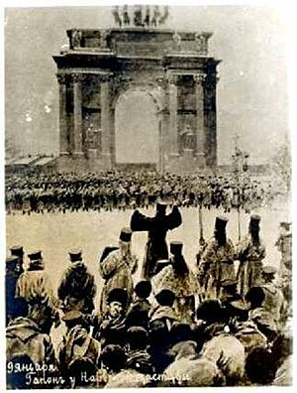
The 1905 Revolution also led to the creation of a parliament,Duma, that would later form the Provisional Government following February 1917.But, the parliament was nothing more than a “bare minimum effort” of Tsar Nicholas to end the revolution.

(Protesters blocking Narva Gate)
Meanwhile, Socialist Revolutionary leaders in exile, many of them living in Switzerland, had been the glum spectators of the collapse of international socialist solidarity. French and German Social Democrats had voted in favor of their respective governments' war efforts. Georgi Plekhanov in Paris had adopted a violently anti-German stand, while Alexander Parvus supported the German war effort as the best means of ensuring a revolution in Russia. The Mensheviks, who were the minority faction after the division of Russian Social Democratic Labour Party, largely maintained that Russia had the right to defend herself against Germany, although Julius Martov (a prominent Menshevik), now on the left of his group, demanded an end to the war and a settlement on the basis of national self-determination, with no annexations or indemnities.^{[7]}
It was these views of Martov that predominated in a manifesto drawn up by Leon Trotsky (at the time a Menshevik) at a conference in Zimmerwald, attended by 35 Socialist leaders in September 1915. Inevitably, Vladimir Lenin, supported by Zinoviev and Radek, strongly contested them. Their attitudes became known as the Zimmerwald Left. Lenin rejected both the defense of Russia and the cry for peace. Since the autumn of 1914, he had insisted that "from the standpoint of the working class and of the laboring masses the lesser evil would be the defeat of the Tsarist Monarchy"; the war must be turned into a civil war of the proletarian soldiers against their own governments, and if a proletarian victory should emerge from this in Russia, then their duty would be to wage a revolutionary war for the liberation of the masses throughout Europe.
That was the general situation of the Revolutionary figures at the time, now if we look back to the Tsar Nicholas’s Reign again;
Workers also had good reasons for discontent: overcrowded housing with often deplorable sanitary conditions, long hours at work (on the eve of the war, a 10-hour workday six days a week was the average and many were working 11–12 hours a day by 1916). Even though serfdom and feudal workers were abolished in Russia in 1861, thus, it was changed with a more malicious, evil, and merciless system; Factory bosses. Which were way worse and harsh to the workers, for the Socialists, that is. Even then, Russian factory workers had the lowest wage in Europe.
The social causes of the Russian Revolution can be derived from centuries of oppression of the lower classes by the Tsarist regime and Nicholas's failures in World War I. While rural agrarian peasants had been emancipated from serfdom in 1861, as mentioned before, they still resented paying redemption payments to the state, and demanded communal tender of the land they worked. The problem was further compounded by the failure of Sergei Witte's land reforms of the early 20th century. Increasing peasant disturbances and sometimes actual revolts occurred, with the goal of securing ownership of the land they worked. Russia consisted mainly of poor farming peasants and substantial inequality of land ownership, with 1.5% of the population owning 25% of the land.

The rapid industrialization of Russia also resulted in urban overcrowding and poor conditions for urban industrial workers (as mentioned above). Between 1890 and 1910, the population of the capital, Saint Petersburg, nearly doubled from 1,033,600 to 1,905,600, with Moscow experiencing similar growth. This created a new 'proletariat' which, due to being crowded together in the cities, was much more likely to protest and go on strike than the peasantry had been in previous times. One 1904 survey found that an average of 16 people shared each apartment in Saint Petersburg, with six people per room. There was also no running water, and piles of human waste were a threat to the health of the workers.

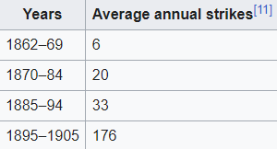

World War I increased the chaos. Conscription throughout Russia led to unwilling residents being despatched off to conflict. The vast demand for factory production of war supplies resulted in lots of greater hard work riots and strikes. Conscription stripped professional people from the towns, who needed to get replaced with unskilled peasants. When famine started to hit because of the bad railway system, people deserted the towns in droves searching for food. Finally, the soldiers themselves, who suffered from a loss of organization and safety from the elements, started to show in opposition to the Tsar. This became in particular because, as the conflict progressed, a number of the officials who have been loyal to the Tsar have been killed, being changed through discontented conscripts from the important towns who had little loyalty to the Tsar.
WORLD WAR I
Despite some reforms that followed the Russo-Japanese War, the Russian army in 1914 was ill-equipped to fight a major war, and neither the political nor the military leadership was up to the standard required.
The outbreak of war in August 1914 initially served to quiet the prevalent social and political protests, focusing hostilities against a common external enemy, but this patriotic unity did not last long. As the war dragged on inconclusively, war-weariness gradually took its toll. On top of that, Russia’s first major battle was a total blunder. Over 30.000 men were massacred on the battlefield and 90.000 of them were captured.
Russia`s terrible overall performance in 1914–1915 brought about developing proceedings directed at Tsar Nicholas II and the Romanov family. A brief wave of patriotic nationalism ended withinside the face of defeats and terrible situations at the Eastern Front of World War I.The Tsar made the situation worse by taking personal control of the Imperial Russian Army in 1915, a challenge far beyond his skills. He was now held PERSONALLY responsible for Russia's continuing defeats and losses in the front and generally.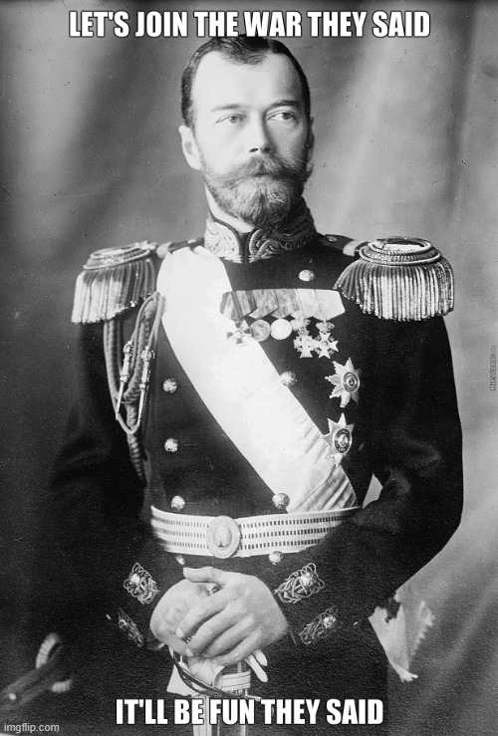

After the entry of the Ottoman Empire on the side of the Central Powers in October 1914, Russia has lost a major trade route to the Mediterranean Sea, which worsened the economic crisis and the munitions shortages.

The conditions during the war resulted in a devastating loss of morale within the Russian army and the general population of Russia itself. This was particularly apparent in the cities, owing to a lack of food in response to the disruption of agriculture. Food scarcity had become a considerable problem in Russia, but the cause of this did not lie in any failure of the harvests, which had not been significantly altered during wartime. The indirect reason was that the government, in order to finance the war, printed millions of ruble notes, and by 1917, inflation had made prices increase up to four times what they had been in 1914.(Tsar Nicholas was a lame-ass ruler fr) Farmers were consequently faced with a higher cost of living, but with little increase in income. As a result, they tended to hoard their grain and to revert to subsistence farming, which meant they only grew their crops enough for the needs of the household, which worsened the overall agriculture and economy that was already terrible.

In 1915, things took a critical turn for the worse when Germany shifted its focus of attack to the Eastern Front. The superior German Army – better led, better trained, and better supplied – was quite effective against the ill-equipped Russian forces, driving the Russians out of Galicia, as well as Russian Poland during the Gorlice–Tarnów Offensive campaign. By the end of October 1916, Russia had lost between 1,600,000 and 1,800,000 soldiers, with an additional 2,000,000 prisoners of war and 1,000,000 missing, all making up a total of nearly 5,000,000 men.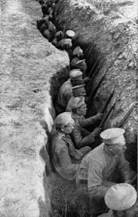
These staggering losses played a definite role in the mutinies and revolts that began to occur. In 1916, reports of fraternizing with the enemy began to circulate. Soldiers went hungry, lacked shoes, munitions, and even weapons. Rampant discontent lowered morale, which was further undermined by a series of military defeats.

Far sooner than expected, inadequately trained recruits were called for active duty, a process repeated throughout the war as staggering losses continued to mount. The officer class also saw remarkable changes, especially within the lower echelons, which were quickly filled with soldiers rising up through the ranks. These men, usually of peasant or working-class backgrounds, were to play a large role in the politicization of the troops in 1917.
The army quickly ran short of rifles and ammunition (as well as uniforms and food), and by mid-1915, men were being sent to the front bearing no arms. It was hoped that they could equip themselves with arms recovered from fallen soldiers, of both sides, on the battlefields. The soldiers did not feel as if they were valuable, rather they felt as if they were expendable. They sustained themselves usually by using makeshift equipments such as gas masks from wools/sacks in Osowiec Fortress Attack 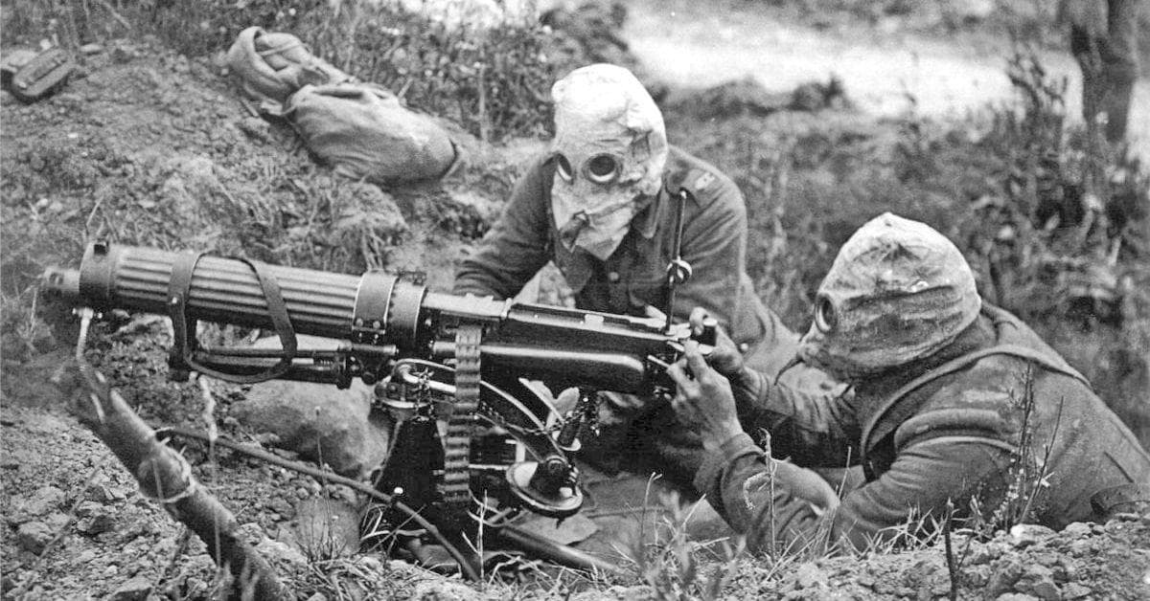
By the spring of 1915, the army was in steady retreat, which was not always orderly; desertion, plundering, mutiny and chaotic flight were not uncommon.The war did not only devastated soldiers. By the end of 1915, there were manifold signs that the economy was breaking down under the heightened strain of wartime demand

Strikes increased steadily from the middle of 1915, and so did crime, but, for the most part, people suffered and endured, scouring the city for food. Working-class women in St. Petersburg reportedly spent about forty hours a week in food lines, begging, turning to prostitution or crime, tearing down wooden fences to keep stoves heated for warmth, and continued to resent the rich..
Tsar Nicholas was blamed for all of these crises, and what little support he had left began to crumble. As discontent grew, the State Duma(the parliament that was established after the 1905 revolution) issued a warning to Nicholas in November 1916, stating that, inevitably, a terrible disaster would grip the country unless a constitutional form of government was put in place.
That brings us to the next phase, the February Revolution.
4)FEBRUARY REVOLUTION
On February 23, 1917, the revolution began, but it was neither organized nor immediately recognized as such by any of the existing parties or political groups. Strikes for higher wages at some of Petrograd’s factories had been occurring sporadically for some time, and on that day no fewer than 130,000 men were picketing. To this total must be added the considerable number of female workers who were celebrating International Women’s Day. The number of strikers and their sympathizers was large, and although several bakers’ shops were demolished by the mob, neither the leaders of the Duma on the one hand nor the imperial government and the police on the other gave the matter any particular attention. The only precaution taken by the authorities was to prevent the demonstrators from reaching the center of the city. The next day the strikers were still more numerous and probably amounted to 30 percent of all workers in Petrograd. Some sections of the crowd succeeded in reaching the city center, and their mood soon became threatening. On that day university students joined the movement, but the primary concern of protesters remained the food shortages that had plagued the capital. Only a few cries were raised denouncing the autocracy and the war.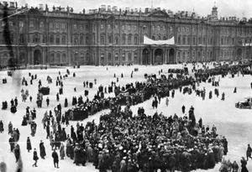
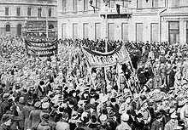

Demonstrations were organized to demand bread, and these were supported by the industrial working force who considered them a reason for continuing the strikes. The women workers marched to nearby factories bringing out over 50,000 workers on strike. By 10 March, virtually every industrial enterprise in Petrograd had been shut down, together with many commercial and service enterprises. Students, white-collar workers, and teachers joined the workers in the streets and at public meetings.
To quell the riots, the Tsar looked to the army. At least 180,000 troops were available in the capital, but most were either untrained or injured. Historian Ian Beckett suggests around 12,000 could be regarded as reliable, but even these proved reluctant to move in on the crowd, since it included so many women. It was for this reason that on 11 March, when the Tsar ordered the army to suppress the rioting by force, troops began to revolt. Although few actively joined the rioting, many officers were either shot or went into hiding; the ability of the garrison to hold back the protests was all but nullified, symbols of the Tsarist regime were rapidly torn down around the city, and governmental authority in the capital collapsed – not helped by the fact that Nicholas had prorogued the Duma that morning, leaving it with no legal authority to act. The response of the Duma, urged on by the liberal bloc, was to establish a Temporary Committee to restore law and order; meanwhile, the socialist parties established the Petrograd Soviet to represent workers and soldiers. The remaining loyal units switched allegiance the next day.
The Tsar directed the royal train back towards Petrograd, which was stopped on 14 March, by a group of revolutionaries at Malaya Vishera. When the Tsar finally arrived at Pskov, the Army Chief Nikolai Ruzsky, and the Duma deputies Alexander Guchkov and Vasily Shulgin suggested in unison that he abdicate the throne. He did so on 15 March , on behalf of himself, and then, having taken advice on behalf of his son, the Tsarevich. Nicholas nominated his brother, the Grand Duke Michael Alexandrovich, to succeed him. But the Grand Duke realized that he would have little support as ruler, so he declined the crown on 16 March, stating that he would take it only if that was the consensus of democratic action. Six days later, Nicholas, no longer Tsar and addressed with contempt by the sentries as "Nicholas Romanov", was reunited with his family at the Alexander Palace at Tsarskoye Selo. He was placed under house arrest with his family by the Provisional Government.
The immediate effect of the February Revolution was a widespread atmosphere of elation and excitement in Petrograd. On 16 March, a provisional government was announced. The center-left was well represented, and the government was initially chaired by a liberal aristocrat, Prince Georgy Yevgenievich Lvov, a member of the Constitutional Democratic Party (KD). The socialists had formed their rival body, the Petrograd Soviet (or workers' council) four days earlier. The Petrograd Soviet and the Provisional Government competed for power over Russia.
5)Dvoyevlastiye(Dual Power)
The effective power of the Provisional Government was challenged by the authority of an institution that claimed to represent the will of workers and soldiers,the Petrograd Soviet Council of Workers' Deputies.The model for the Soviets were workers' councils that had been established in scores of Russian cities during the 1905 Revolution. In February 1917, striking workers elected deputies to represent them and socialist activists began organizing a citywide council to unite these deputies with representatives of the socialist parties. On 27 February, socialist Duma deputies, mainly Mensheviks and Socialist Revolutionaries, took the lead in organizing a citywide council. The Petrograd Soviet met in the Tauride Palace, room 13, permitted by the Provisional Government.
The leaders of the Petrograd Soviet believed that they represented particular classes of the population, not the whole nation. They also believed Russia was not ready for socialism. They viewed their role as limited to pressuring hesitant "bourgeoisie" to rule and to introduce extensive democratic reforms in Russia (the replacement of the monarchy by a republic, guaranteed civil rights, a democratic police and army, abolition of religious and ethnic discrimination, preparation of elections to a constituent assembly, and so on). They met in the same building as the emerging Provisional Government not to compete with the Duma Committee for state power, but to exert pressure on the new government, to act, in other words, as a popular democratic lobby.

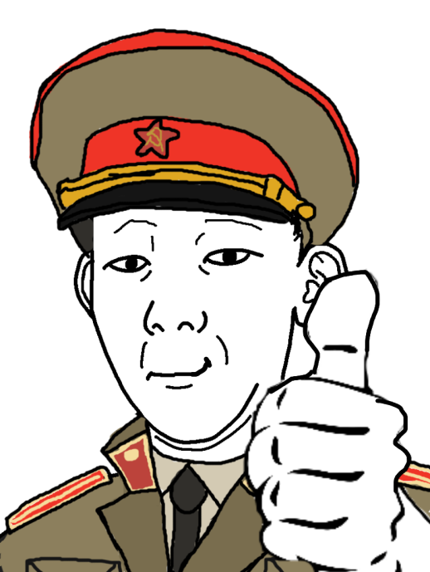
The relationship between these two major powers was complex from the beginning and would shape the politics of 1917. The representatives of the Provisional Government agreed to "take into account the opinions of the Soviet of Workers' Deputies", though they were also determined to prevent interference which would create an unacceptable situation of dual power. In fact, this was precisely what was being created, though this "dual power" (dvoyevlastiye) was the result less of the actions or attitudes of the leaders of these two institutions than of actions outside their control, especially the ongoing social movement taking place on the streets of Russia's cities, factories, shops, barracks, villages, and in the trenches.
A series of political crises in the relationship between population and government and between the Provisional Government and the Soviets (which developed into a nationwide movement with a national leadership). The All-Russian Central Executive Committee of Soviets (VTsIK) undermined the authority of the Provisional Government but also of the moderate socialist leaders of the Soviets.
Although the Soviet leadership initially refused to participate in the "bourgeois" Provisional Government, Alexander Kerensky, a young, popular lawyer and a member of the Socialist Revolutionary Party (SRP), agreed to join the new cabinet, and became an increasingly central figure in the government, eventually taking leadership of the Provisional Government. As minister of war and later Prime Minister, Kerensky promoted freedom of speech, released thousands of political prisoners, continued the war effort, even organizing another offensive (which, however, was no more successful than its predecessors). Nevertheless, Kerensky still faced several great challenges, highlighted by the soldiers, urban workers, and peasants, who claimed that they had gained nothing by the revolution:
1)Other political groups were trying to undermine him.

2)Heavy military losses were being suffered on the front.

3)The soldiers were dissatisfied and demoralized and had started to defect. (On arrival
back in Russia, these soldiers were either imprisoned or sent straight back into the front.)

4)There was enormous discontent with Russia's involvement in the war, and many were calling for an end to it.

5)There were great shortages of food and supplies, which was difficult to remedy because of the wartime economic conditions.
The political group that proved most troublesome for Kerensky, and would eventually overthrow him, was the Bolshevik Party, led by Vladimir Lenin. Lenin had been living in exile in neutral Switzerland and, due to democratization of politics after the February Revolution, which legalized formerly banned political parties, he perceived the opportunity for his Marxist revolution. Although returning to Russia had become a possibility, the war made it logistically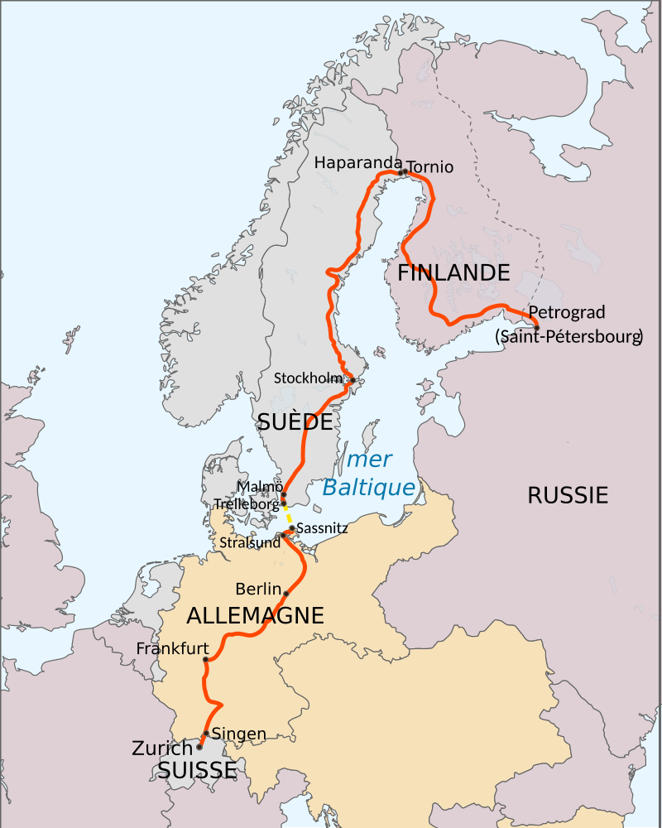
difficult. Eventually, German officials arranged for Lenin to pass through their territory, hoping that his activities would weaken Russia or even lead to Russia's withdrawal from the war. Lenin and his associates, however, had to agree to travel to Russia in a sealed train: Germany would not take the chance that he would foment revolution in Germany. After passing through the front, he arrived in Petrograd in
April 1917.

On the way to Russia, Lenin prepared the April Theses, which outlined central Bolshevik policies. These included Soviets taking power and denouncing the liberals and social revolutionaries in the Provisional Government, forbidding co-operation with it. Many Bolsheviks, however, had supported the Provisional Government.

With Lenin's arrival, the popularity of the Bolsheviks increased steadily. Over the course of the spring, public dissatisfaction with the Provisional Government and the war, in particular among workers, soldiers and peasants, pushed these groups to radical parties. Despite growing support for the Bolsheviks, buoyed by maxims that called most famously for "all power to the Soviets", the party held very little real power in the moderate-dominated Petrograd Soviet. In fact, historians such as Sheila Fitzpatrick have asserted that Lenin's exhortations for the Soviet Council to take power were intended to arouse indignation both with the Provisional Government, whose policies were viewed as conservative, and the Soviets themselves, which were viewed as subservients to the conservative government. By some other historians' accounts, Lenin and his followers were unprepared for how their groundswell of support, especially among influential worker and soldier groups, would translate into real power in the summer of 1917.

On 18 June, the Provisional Government launched an attack against Germany that failed miserably. Soon after, the government ordered soldiers to go to the front, reneging on a promise. The soldiers refused to follow the new orders. The arrival of radical Kronstadt sailors – who had tried and executed many officers, including one admiral – further fueled the growing revolutionary atmosphere. Sailors and soldiers, along with Petrograd workers, took to the streets in violent protest, calling for "all power to the Soviets". The revolt, however, was disowned by Lenin and the Bolshevik leaders and dissipated within a few days. In the aftermath, Lenin fled to Finland under threat of arrest while Trotsky, among other prominent Bolsheviks, was arrested. The Bolshevik’s unpreparedness at the moment of revolt was an embarrassing gaffe that lost them support among their main constituent groups: soldiers and workers.(Huge L take tbh)
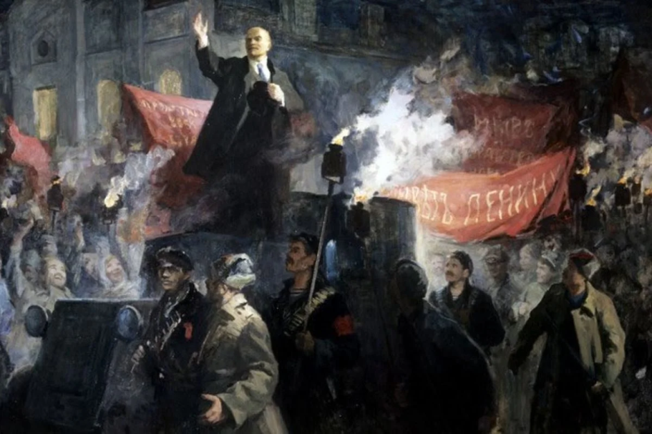
The Bolshevik failure proved temporary. The Bolsheviks had undergone a spectacular growth in membership. Whereas, in February 1917, the Bolsheviks were limited to only 24,000 members, by September 1917 there were 200,000 members of the Bolshevik faction.

In August, poor and misleading communication led General Lavr Kornilov, the recently appointed Supreme Commander of Russian military forces, to believe that the Petrograd government had already been captured by radicals, or was in serious danger thereof. In response, he ordered troops to Petrograd to pacify the city. To secure his position, Kerensky had to ask for Bolshevik assistance(big blunder). He also sought help from the Petrograd Soviet, which called upon armed Red Guards to "defend the revolution". The Kornilov Affair failed largely due to the efforts of the Bolsheviks, whose influence over railroad and telegraph workers proved vital in stopping the movement of troops. With his coup failing, Kornilov surrendered and was relieved of his position. The Bolsheviks' role in stopping the attempted coup further strengthened their position.

In early September, the Petrograd Soviet freed all jailed Bolsheviks and Trotsky became chairman of the Petrograd Soviet. Growing numbers of socialists and lower-class Russians viewed the government less as a force in support of their needs and interests. The Bolsheviks benefited as the only major organized opposition party that had refused to compromise with the Provisional Government, and they benefited from growing frustration and even disgust with other parties, such as the Mensheviks and Socialist Revolutionaries, who stubbornly refused to break with the idea of national unity across all classes.

In Finland, Lenin had worked on his book State and Revolution and continued to lead his party, writing newspaper articles and policy decrees. By October, he returned to Petrograd, aware that the increasingly radical city presented him no legal danger and a second opportunity for revolution. Recognising the strength of the Bolsheviks, Lenin began pressing for the immediate overthrow of the Kerensky government by the Bolsheviks. Lenin was of the opinion that taking power should occur in both St. Petersburg and Moscow simultaneously, parenthetically stating that it made no difference which city rose up first. The Bolshevik Central Committee drafted a resolution, calling for the dissolution of the Provisional Government in favor of the Petrograd Soviet. The resolution was passed 10–2 (Lev Kamenev and Grigory Zinoviev prominently dissenting) promoting the October Revolution.
6)October Revolution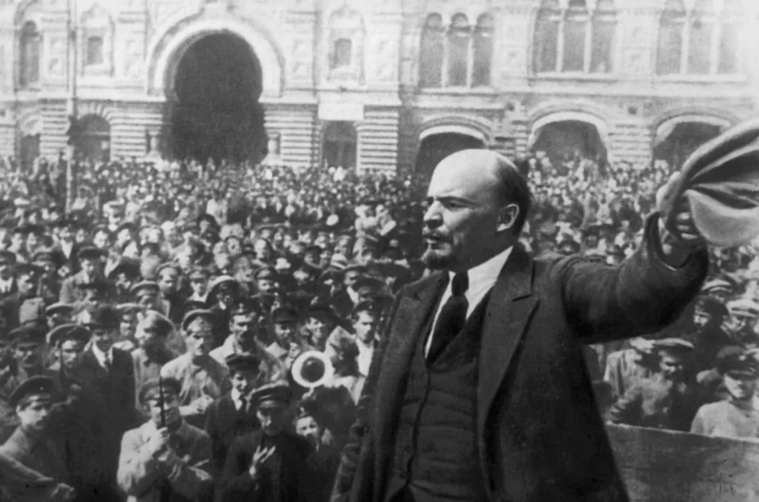
The October Revolution, which unfolded on Wednesday 7 November 1917 according to the Gregorian calendar and on Wednesday 25 October according to the Julian calendar in use under tsarist Russia, was organized by the Bolshevik party. Lenin did not have any direct role in the revolution and he was hiding for his personal safety. However, in late October, Lenin secretly and at great personal risk entered Petrograd and attended a private gathering of the Bolshevik Central Committee on the evening of October 23.
The Revolutionary Military Committee established by the Bolshevik party was organizing the insurrection and Leon Trotsky was the chairman. 50,000 workers had passed a resolution in favor of Bolshevik demand for transfer of power to the soviets. However, Lenin played a crucial role in the debate in the leadership of the Bolshevik party for a revolutionary insurrection as the party in the autumn of 1917 received a majority in the soviets. An ally in the left fraction of the Revolutionary-Socialist Party, with huge support among the peasants who opposed Russia's participation in the war, supported the slogan 'All power to the Soviets'.The initial stage of the October Revolution which involved the assault on Petrograd occurred largely without any human casualties.

Liberal and monarchist forces, loosely organized into the White Army, immediately went to war against the Bolsheviks' Red Army, in a series of battles that would become known as the Russian Civil War. This did not happen in 1917. The Civil War began in early 1918 with domestic anti-Bolshevik forces confronting the nascent Red Army. In autumn of 1918 Allied countries needed to block German access to Russian supplies. They sent troops to support the "Whites" with supplies of weapons, ammunition and logistic equipment being sent from the main Western countries but this was not at all coordinated. Germany did not participate in the civil war as it surrendered to the Allied.

Lenin did not believe that a socialist revolution necessarily presupposed a fully developed capitalist economy. A semi-capitalist country would suffice and Russia had a working class base of 5% of the population.
Though Lenin was the leader of the Bolshevik Party, it has been argued that since Lenin was not present during the actual takeover of the Winter Palace, it was really Trotsky's organization and direction that led the revolution, merely spurred by the motivation Lenin instigated within his party. Bolshevik figures such as Anatoly Lunacharsky, Moisei Uritsky and Dmitry Manuilsky agreed that Lenin’s influence on the Bolshevik party was decisive but the October insurrection was carried out according to Trotsky’s, not to Lenin’s plan
Soviet membership was initially freely elected, but many members of the Socialist Revolutionary Party, anarchists, and other leftists created opposition to the Bolsheviks through the Soviets themselves. The elections to the Russian Constituent Assembly took place 25 November 1917. The Bolsheviks gained 25% of the vote. When it became clear that the Bolsheviks had little support outside of the industrialized areas of Saint Petersburg and Moscow, they simply barred non-Bolsheviks from membership in the Soviets. The Bolsheviks dissolved the Constituent Assembly in January 1918.

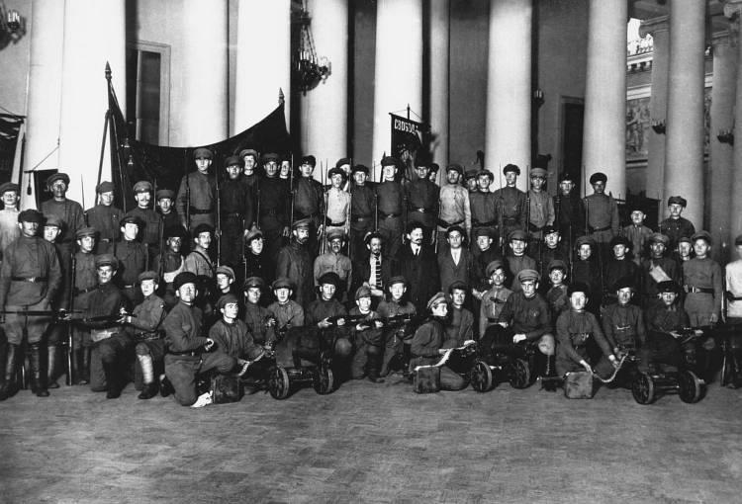
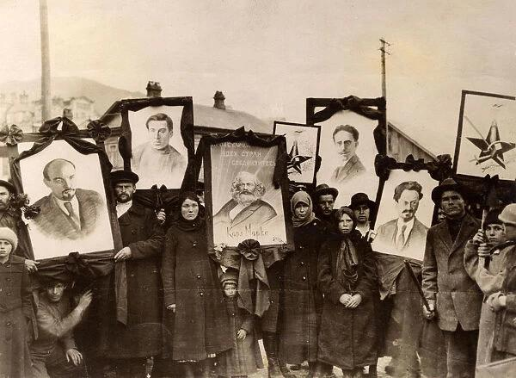
7)RUSSIAN CIVIL WAR
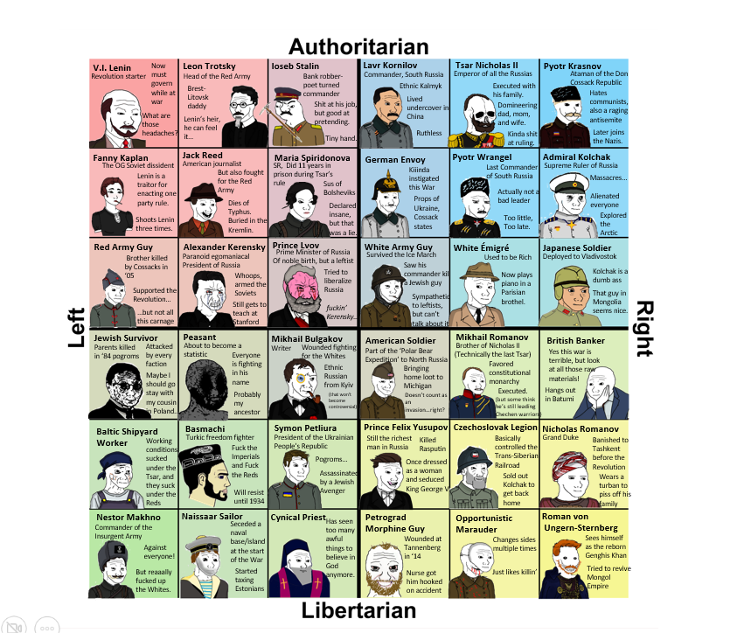

The Russian Civil War, which broke out in 1918 shortly after the October Revolution, resulted in the deaths and suffering of millions of people regardless of their political orientation. The war was fought mainly between the Red Army ("Reds"), consisting of the uprising majority led by the Bolshevik minority, and the "Whites" – army officers and cossacks, the "bourgeoisie", and political groups ranging from the far Right, to the Socialist Revolutionaries who opposed the drastic restructuring championed by the Bolsheviks following the collapse of the Provisional Government, to the Soviets (under clear Bolshevik dominance). The Whites had backing from other countries such as the United Kingdom, France, the United States, and Japan, while the Reds possessed internal support, proving to be much more effective. Though the Allied nations, using external interference, provided substantial military aid to the loosely knit anti-Bolshevik forces, they were ultimately defeated.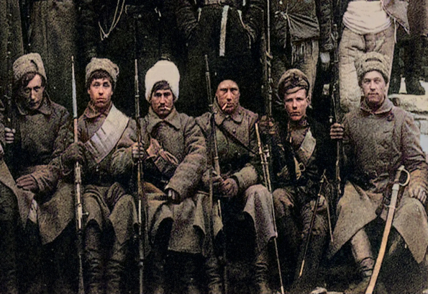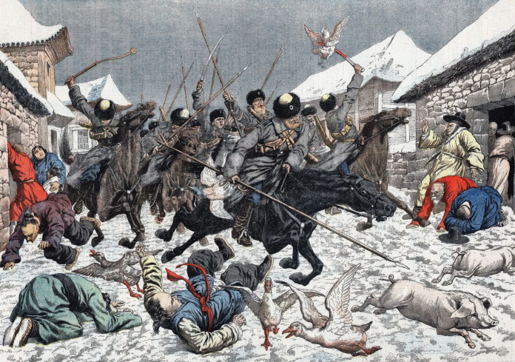

The Bolsheviks firstly assumed power in Petrograd, expanding their rule outwards. They eventually reached the Easterly Siberian Russian coast in Vladivostok, four years after the war began, an occupation that is believed to have ended all significant military campaigns in the nation. Less than one year later, the last area controlled by the White Army, the Ayano-Maysky District, directly to the north of the Krai containing Vladivostok, was given up when General Anatoly Pepelyayev capitulated in 1923.

Several revolts were initiated against the Bolsheviks and their army near the end of the war, notably the Kronstadt Rebellion. This was a naval mutiny engineered by Soviet Baltic sailors, former Red Army soldiers, and the people of Kronstadt. This armed uprising was fought against the antagonizing Bolshevik economic policies that farmers were subjected to, including seizures of grain crops by the Communists.This all amounted to large-scale discontent. When delegates representing the Kronstadt sailors arrived at Petrograd for negotiations, they raised 15 demands primarily pertaining to the Russian right to freedom. The Government firmly denounced the rebellions and labeled the requests as a reminder of the Social Revolutionaries, a political party that was popular among Soviets before Lenin, but refused to cooperate with the Bolshevik Army. The Government then responded with an armed suppression of these revolts and suffered ten thousand casualties before entering the city of Kronstadt. This ended the rebellions fairly quickly, causing many of the rebels to flee seeking political exile.
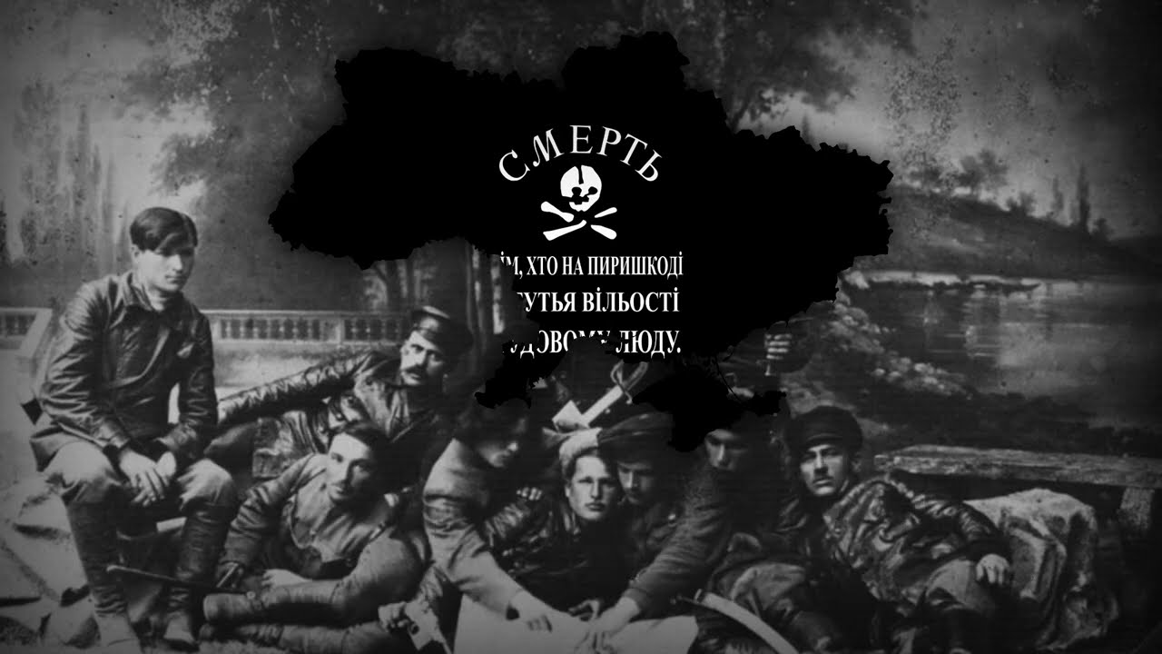
During the Civil War, Nestor Makhno led a Ukrainian anarchist movement. Makhno's Insurgent Army allied to the Bolsheviks thrice, with one of the powers ending the alliance each time. However, a Bolshevik force under Mikhail Frunze destroyed Makhnovshchina, when the Makhnovists refused to merge into the Red Army. In addition, the so-called "Green Army" (peasants defending their property against the opposing forces) played a secondary role in the war, mainly in Ukraine.

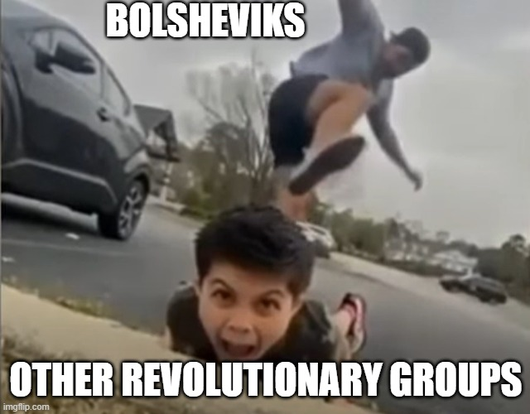

Revolutionary tribunals
Revolutionary tribunals were present during both the Revolution and the Civil War, intended for the purpose of combating forces of counter-revolution. At the Civil War's zenith, it is reported that upwards of 200,000 cases were investigated by approximately 200 tribunals. These tribunals established themselves more so from the Cheka as a more moderate force that acted under the banner of revolutionary justice, rather than a utilizer of strict brute force as the former did. Revolutionary tribunals ultimately demonstrated that a form of justice was still prevalent in Russian society where the Russian Provisional Government failed. This, in part, triggered the political transition of the October Revolution and the Civil War that followed in its aftermath.

Murder of the Imperial Family
The Bolsheviks murdered the Tsar and his family on 16 July 1918. In early March 1917, the Provisional Government had placed Nicholas and his family under house arrest in the Alexander Palace at Tsarskoye Selo, 24 kilometers south of Petrograd. But in August 1917, they evacuated the Romanovs to Tobolsk in the Urals to protect them from the rising tide of revolution. After the Bolsheviks came to power in October 1917, the conditions of their imprisonment grew stricter and talk of putting Nicholas on trial increased. In April and May 1918, the looming civil war led the Bolsheviks to move the family to the stronghold of Yekaterinburg. During the early morning of 16 July, Nicholas, Alexandra, their children, their physician, and several servants were taken into the basement and shot.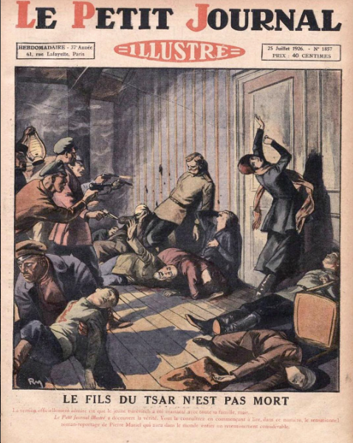

Revolution and The World
The revolution ultimately led to the establishment of the future Soviet Union as an ideocracy; however, the establishment of such a state came as an ideological paradox, as Marx's ideals of how a socialist state ought to be created were based on the formation being natural and not artificially incited (i.e. by means of revolution). Leon Trotsky said that the goal of socialism in Russia would not be realized without the success of the world revolution. A revolutionary wave caused by the Russian Revolution lasted until 1923, but despite initial hopes for success in the German Revolution of 1918–19, the short-lived Hungarian Soviet Republic, and others like it, only the Mongolian Revolution of 1921 saw a Marxist movement at the time succeed in keeping power in its hands.

CURRENT STATE OF THE UNION(1922)
A)ECONOMY AND AGRICULTURE

In 1922, the Soviet Union was just beginning to recover from the devastation of the Russian Revolution, and the Civil War. The economy was in a dire state, characterized by widespread destruction of infrastructure, industry, and agriculture.

During the Civil War, the Bolshevik government implemented "War Communism" to maintain control over resources. This included the nationalization of all industries, forced requisitioning of grain from peasants, and centralized control of the economy. This system led to mass starvation, hyperinflation, and economic collapse.

Industrial output fell to around 20% of its pre-war levels, and agricultural output dropped by about 40%.

In response to the economic crisis, Lenin introduced the New Economic Policy in 1921. The NEP marked a partial retreat from strict socialist policies and allowed limited private ownership and small-scale capitalist ventures, especially in agriculture and small industries. Peasants were allowed to sell their surplus produce in open markets, and small businesses could operate for profit, while the state retained control of heavy industries, banking, and foreign trade. This led to a recovery in agricultural production and small-scale industry, helping to stabilize the economy by 1922, though it was still fragile.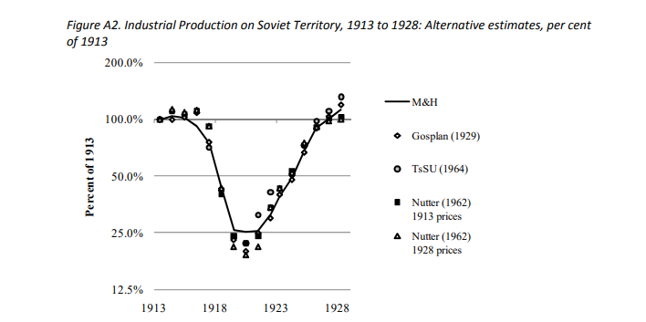

By 1922, the USSR's economy was beginning to stabilize. Agricultural output began to improve, and some level of trade resumed. However, industrial output was still significantly lower than pre-war levels.
Hyperinflation was curbed, and the ruble was replaced with the "chervonets" to stabilize the currency. The economy was still heavily agrarian, with over 80% of the population engaged in agriculture, and the industrial base was weak compared to pre-revolutionary times.
The economic problems in agriculture were further exacerbated by natural conditions, such as long cold winters across the country, droughts in the south and acidic soils in the north. However, according to Dyker, the Soviet economy did have "extremely good" potential in the area of raw materials and mineral extraction, for example in the oil fields in Transcaucasia, and this, along with a small but growing manufacturing base, helped the Soviet Union avoid any kind of balance of payments problems.

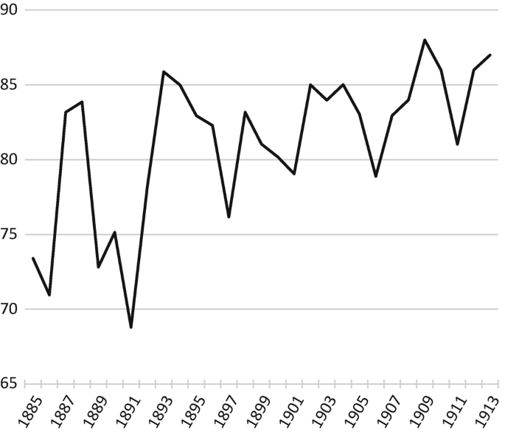

AGRICULTURAL PRODUCTION 1885-1913
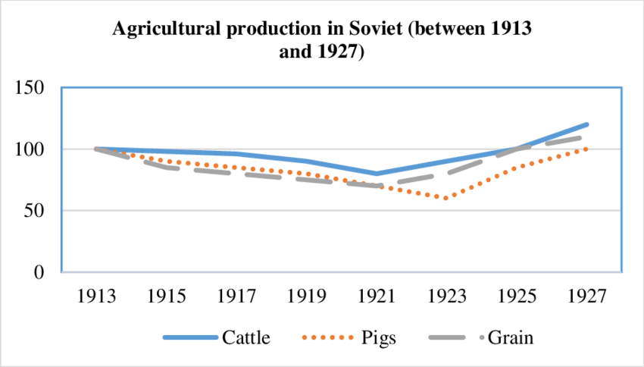

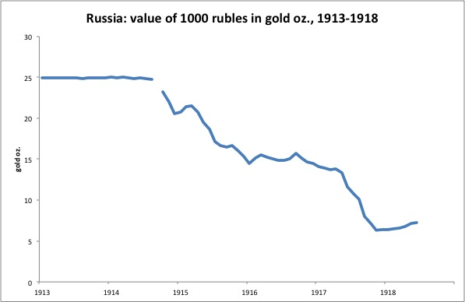

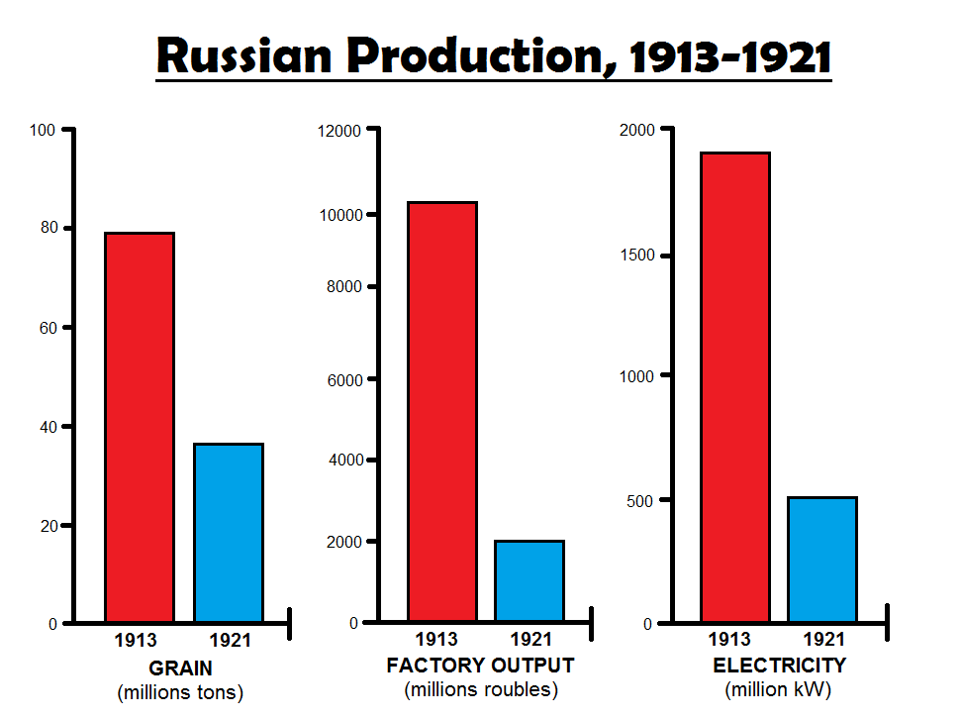
B)EDUCATION
In 1922, the education system in the Soviet Union was undergoing a major transformation following the Russian Revolution of 1917. The Bolshevik government prioritized education as a tool for building socialism and reducing illiteracy, which was widespread in the early Soviet period.
In 1922, a significant portion of the population was illiterate, especially in rural areas. Estimates suggest that around 70-80% of the population could not read or write at the time of the Russian Revolution in 1917.
This was particularly problematic among peasants and working-class communities, while the urban, educated elite had higher literacy rates.
The Bolsheviks saw education as essential to creating a class-conscious socialist society. The government initiated a mass literacy campaign called Likbez, meaning "liquidation of illiteracy." This movement aimed to teach reading and writing to adults, particularly targeting workers and peasants.
The new regime placed a strong emphasis on secular education, eradicating the influence of the Orthodox Church, which had previously dominated education in Tsarist Russia.

Education was made free and compulsory for children. The state took control of schools, and a curriculum was developed that aligned with socialist ideals, including Marxist-Leninist theory, basic literacy, numeracy, and technical skills needed for industrial work.
Schooling was divided into primary, secondary, and technical levels, with increasing emphasis on vocational training to support the planned industrial economy.
Alongside traditional subjects, a significant part of the curriculum focused on Marxist ideology, with the goal of creating loyal Soviet citizens. History and social studies were taught from a communist perspective, emphasizing class struggle and the role of the proletariat in overthrowing capitalism.
Due to the economic devastation caused by World War I, the Civil War, and subsequent famine, the Soviet government struggled to fund its ambitious educational reforms. Many schools lacked adequate facilities, teachers, and materials, but efforts continued to expand education to the masses.
Higher education was also reorganized in line with socialist principles. The government established new technical institutes and universities to train a cadre of engineers, scientists, and teachers needed for the modernization of the country.
C)INTERNATIONAL AND INTERNAL RELATIONS
C-1)International Relations
In 1922, the Soviet Union was in its birth, having only recently emerged from the devastation of the the Civil War. Its relationships both internationally and internally were complex and often tense as it sought to consolidate power domestically while navigating a largely hostile international environment.
The Soviet Union was generally isolated from the international community in 1922, as many Western countries viewed communism as a threat to their own capitalist and democratic systems. Most Western governments, especially the U.S. and the British Empire, were wary of the new communist regime and hesitant to recognize it diplomatically due to its calls for global revolution and the overthrow of capitalism.

One of the USSR's first major diplomatic successes was with Germany. The Treaty of Rapallo, signed on April 16, 1922, established diplomatic and economic relations between the two countries.
This treaty allowed both nations to bypass Western sanctions and isolation, as Germany was also economically strained after World War I and resentful of the Treaty of Versailles. In addition to trade and economic cooperation, there was secret military collaboration, with Germany using Soviet land to test weapons and train soldiers.
Despite international hostility, some countries saw economic benefits in engaging with the Soviet Union, particularly for trade purposes. The British, for example, entered a temporary trade agreement with the USSR in 1921, allowing limited economic relations.
These trade relationships were practical rather than ideological, as Western economies were dealing with post-war recovery and Soviet resources, particularly grain and raw materials, were attractive.
The USSR aimed to solidify its influence over neighboring regions, including the Baltic states, Central Asia, and the Caucasus. By 1922, regions such as Ukraine, Belarus, Armenia, Azerbaijan, and Georgia had been incorporated into the USSR.
Relations with neighboring Poland were tense after the Polish-Soviet War (1919-1921), where the Soviets attempted to push westward but were defeated, resulting in the Treaty of Riga (1921). This loss limited Soviet influence in Eastern Europe temporarily.
C-2)Internal Relations
On December 30, 1922, the Soviet Union was formally established as a union of Soviet republics, bringing together Russia, Ukraine, Belarus, and the Transcaucasian Republic (Georgia, Armenia, and Azerbaijan).
After the Civil War, the Bolsheviks focused on eliminating opposition within the USSR, using the Cheka (secret police) to suppress dissent and any anti-communist groups.
The Bolsheviks also took steps to centralize power under the Communist Party, implementing strict control over the press, political organizations, and public life. This move alienated some factions that had initially supported the Revolution but opposed the Communist Party's authoritarian tendencies.

The New Economic Policy (NEP) was introduced in 1921 to revitalize the economy by allowing limited private enterprise and market mechanisms, especially in agriculture. While it boosted the economy, it also created tension within the Communist Party between those who saw it as a necessary step and others who viewed it as a betrayal of socialist principles.
Class relations were complicated; peasants were allowed to sell surplus crops in open markets under the NEP, but urban workers often faced shortages and poor conditions. The USSR’s policy was to foster a “proletarian” consciousness, but the gap between the rural and urban populations remained challenging.
The Soviet Union was a multi-ethnic empire with dozens of nationalities. The government promoted “korenizatsiya” or “indigenization” policies, encouraging ethnic representation in local governments and the use of local languages. However, these policies often conflicted with Moscow’s centralized control.
Regions with strong national identities, such as Ukraine and Georgia, posed particular challenges to the Soviet leadership, which wanted to integrate these areas without sparking nationalist uprisings.
The Soviet government pursued a strict policy of atheism, viewing religion as incompatible with communist ideology. The Russian Orthodox Church, which had previously been close to the Tsarist regime, faced severe repression, with church properties seized, clergy arrested, and religious activities curtailed.
This policy of religious repression led to some resistance from rural and devout populations, who viewed the Soviet government’s anti-religious stance with suspicion or outright hostility.
D)MILITARY
The Civil War had left the Red Army depleted but battle-hardened. The war had been brutal, involving clashes with the White Army and interventions by foreign powers (UK, USA, Japan, and France). By 1922, the Red Army was victorious, but it needed restructuring and replenishment.
Following the war, the army faced severe shortages in manpower, equipment, and resources. Many soldiers were demobilized or returned to civilian life, while others stayed in active service as the government sought to establish a smaller, professional army rather than a massive, wartime conscript force.

After the Civil War, Soviet leaders recognized the need for a more organized and disciplined military. Under the leadership of Leon Trotsky the Red Army was professionalized, with standardized ranks, training programs, and recruitment of experienced officers, including former Tsarist officers.
A military education system was developed to train the new generation of Soviet officers, including military academies and training schools, while also building loyalty to the Communist Party.
To ensure loyalty, the Red Army integrated political commissars into its structure. These commissars were Communist Party representatives within military units who were responsible for ideological training, ensuring soldiers’ allegiance to Soviet ideals, and preventing anti-Bolshevik sentiment.
This mix of military command with political oversight was designed to secure the Red Army’s commitment to the Communist Party and protect it from counter-revolutionary influences.
The Soviet Union struggled with resource limitations and outdated equipment, largely due to economic devastation from the war and international isolation. While the NEP helped revive the economy, industrial production had not yet recovered to a level that could sustain a well-equipped, modern army.
The Communist Party maintained tight control over the Red Army, ensuring it would not develop into an independent political force. Military leaders were carefully chosen based on their political reliability, and the army was deeply intertwined with the state’s political objectives.
E)INDUSTRY
By 1922, the Soviet Union’s industrial output had drastically fallen. Factories were damaged, equipment was outdated, and there were severe shortages of raw materials. Industrial production was estimated to be at roughly 20% of pre-World War I levels.(Previously mentioned in the economy-agriculture part.)
The NEP allowed for some private ownership in small businesses and consumer goods manufacturing, but heavy industry, banking, and foreign trade remained state-controlled.(mentioned before, again.)
This policy brought back small-scale private enterprise and foreign trade, which helped boost consumer goods production and revitalize urban economies. However, large-scale heavy industry was still slow to recover, remaining under state management.
Labor productivity in 1922 was low due to the depletion of the workforce, inadequate wages, and lack of incentives for workers. The factory conditions were often poor, and workers faced long hours with limited access to resources.
To address this, the state focused on recruiting and training new workers, although the overall skills gap remained a significant challenge.
Soviet leaders saw electrification as key to industrial modernization and productivity. GOELRO (State Commission for Electrification of Russia), initiated in 1920, aimed to build hydroelectric power stations and improve power supply to factories and urban areas.
By 1922, progress was still limited, but electrification efforts laid the groundwork for future industrial growth and expansion of heavy industry.
IMPORTANT NOTE:
Dear delegates, the changes/treaties/policies mentioned in the “Current Situation” part are not considered to have occurred during the committee.
Yes, the New Economic Policy will be considered to have happened to lay the groundwork, BUT, this doesn’t apply to other radical changes such as; intelligence agencies or police forces reform(CHEKA)/economic policies, trade treaties/industrial plans/assimilation policies/education policies/military reforms etc.
We just showed you what has been done throughout the early years of the Soviet Union to give you a reference point. We expect you to either follow the footsteps of the Union and develop them, or to find better(or worse) alternatives to history.
Either way, you have the responsibility on your shoulders to turn this war-torn but glorious state into one of the greatest powers the world has yet to see. We believe in you, good luck.

